EE4902 Part 2 Assignment 3

Name: Lim Jia Song John

Matriculation Number: U1321554J

# Investigate the role of sigma in Gaussian smoothing, influence of initialization, effects of alpha and beta in the energy function, ability to deal with corner points.

## Role of Sigma in Gaussian Smoothing

Gaussian Filter is a low pass filter, which essential blurs or smooths the image. The role of sigma in the Gaussian filter is to control the variation around its mean value. So as the sigma becomes larger the more variance allowed around mean and as the sigma becomes smaller the less variance allowed around mean. The higher the value of sigma, the more blurring occurs.

Table ‑ Effect of Gaussian smoothing on snake

|  |  |  |
| --- | --- | --- |
| Blurred Image | Standard Potential Field | After 40 iterations |
|  | $$σ=0$$ |  |
|  | $$σ=1$$ |  |
|  | $$σ=2$$ |  |
|  | $$σ=3$$ |  |

The value of sigma also affects the standard potential field. High sigma increases the speed of deformation. As seen, with increasing sigma, the external force exerted has a larger area of influence. As such, the force exerted can pull the green contour quickly. The tradeoff, however, is that the original image becomes blurred. As a result, the snake converges to a shape that is Gaussian blurred. Critical details about the image are lost, such as sharp corners or fine detail. Generally, the GVF is preferable for increasing the speed of deformation because the GVF does not blur the image itself. However, sometimes a Gaussian blur may be used in smoothing out noise. On the other hand, the GVF is unable to smooth out noise, so it will propagate fields out of the noisy part of the image as well, which is not desirable.

## Influence of initialization

The initial position of the curve affects whether it converges to a solution or not. To optimize the performance of the snake, the approximate shape and size of the image should be known.

When the initial curve is initialized too far away from the original image, it takes significantly more iterations to converge to a solution. The speed of convergence is also smaller. This is because when the initial curve is far away from the original image, the external force applied to ‘shrink’ the initial curve is very small. If the initial curve is too far away, the external force applied to shrink the initial curve is so small that the curve may never converge at all.

The following results were obtained at $σ=1$, and different positions of initialization were created to demonstrate the effect that initialization has on whether the snake converges.

Table ‑ Effect of initialization on snake

|  |  |  |
| --- | --- | --- |
| Radius | Initialization | 40 Iterations |
| 0.45 |  |  |
| 0.55 |  |  |
| 0.65 |  |  |
| 0.75 |  |  |

## Effects of alpha beta in the energy function

The ability of the snake to shrink to a shape depends is dependent on its internal energy and the external energy that is acting on the snake. The external energy is exerted by the original image onto the snake and produces a standard potential field.

$$E_{external}= \int_{s}{E_{image}\left(v\left(s\right)\right)ds}$$

The total internal energy consists of the elastic energy and the bending energy, as follows:

$$E_{internal}=E_{elastic}+ E_{bending}$$

### Elastic Potential Energy

The curve is treated as an elastic rubber band possessing elastic potential energy

$$E_{elastic}=\frac{1}{2}\int_{s}{α\left(s\right){\left|v_{s}\right|}^{2}}ds$$

The weight α (s) allows us to control elastic energy along different parts of contour. It is set as a constant independent of s for many applications. It discourages stretching by introducing tension. It is responsible for shrinking the contour. Having α allows the snake to shrink even without the presence of an external field. When $α$ is larger, the snake shrinks faster. When $α$ is zero, the snake does not have the internal energy to shrink at all.

### Bending Energy

The snake is also considered to behave like a thin metal plate giving rise to bending energy.

$$E_{bending}=\frac{1}{2}\int_{s}{β\left(s\right){\left|v_{ss}\right|}^{2}ds}$$

Bending energy tries to smooth out the shape contour. Bending energy is minimum for a circle.

## Ability to deal with corner points

The ability of the snake to deal with corner points is affected by its internal bending energy. High bending energy eliminates corners in the snake, so the snake tends to converge into a circle. This is not to be confused with the effect of sigma in eliminating corners in the original image.

The following series of images were for a square contour, with $α=0$. The square contour is drawn such that the external force has no effect on the snake.

|  |  |  |
| --- | --- | --- |
| $$β=0$$ | $$β=5$$ | $$β=15$$ |
|  |  |  |

# Investigate the performance of the GVF method.

What the GVF method does is that it iteratively expands the field lines of the standard vector field. With more field lines, the snake will converge much faster.

|  |  |  |
| --- | --- | --- |
| 1 iteration | 2 iterations | 10 iterations |
|  |  |  |

|  |  |  |
| --- | --- | --- |
| R = 0.45 | Traditional Snake | GVF method |
| Initial |  |  |
| After |  |  |

|  |  |  |
| --- | --- | --- |
| R = 0.75 | Traditional Snake | GVF method |
| Initial |  |  |
| After |  |  |

The GVF method also overcomes the problems of the concave boundary as the field is able to pull the snake into the boundary cavity.

|  |  |  |
| --- | --- | --- |
| R = 0.75 | Traditional Snake – SVF method | GVF method |
| Initial |  |  |
| After |  |  |

The traditional Standard Vector Field method is unable to pull the snake into the boundary cavity. If we examine the field lines, we see from Figure 1 that there is no downward component of the field line.

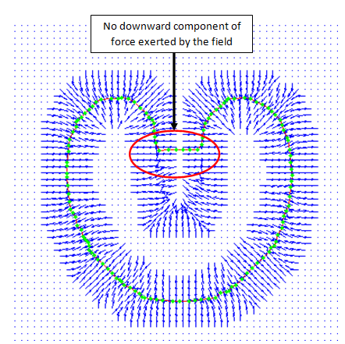

Figure 1 SVF Concave boundary

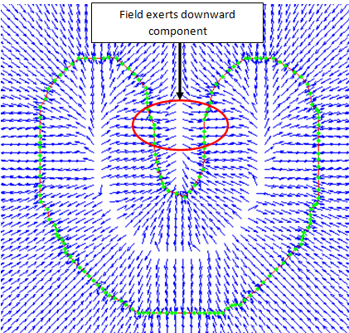

Figure 2 GVF Concave Boundary

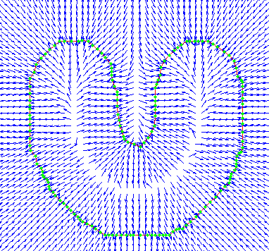

Field exerts downward component

# Experiment with rectangular (or other) shapes using binary images to perform your analysis.

# Investigate the feasibility of initializing completely inside the object and expanding the snake outwards using only the gradient (external energy). When the snake stabilizes, you can introduce both the internal energy and external energy

$α$ can only shrink the snake. In this case, the snake was initialized inside of the shape, such that the external force is not exerted onto the snake. The result is that the snake is shrunk, and is unable to conform to the shape.

|  |  |  |
| --- | --- | --- |
|  |  |  |
| SVF |  |  |
|  |  |  |
|  |  |  |

|  |  |  |
| --- | --- | --- |
|  |  |  |
| GVF = 3  Only external force is affecting the snake  40 iterations |  |  |
| GVF = 3  Set alpha to a large value.  Alpha negatively affects the ability of the snake to conform to the image. |  |  |
|  |  |  |